Subject Name: **Source Code Management**

Subject Code: **CS181**

Cluster: **Beta**

Department: **DCSE**

|  |  |  |
| --- | --- | --- |
| **Submitted By:**  ABHINAV RAWAT  2110990055  G01 |  | **Submitted To:**  Dr. Monit Kapoor |





**Experiment No. 01**

**Aim:** To set up Git Client.

**Procedure:**

1. Visit the provided link for the installation of git in your system.

<https://git-scm.com/downloads>

1. 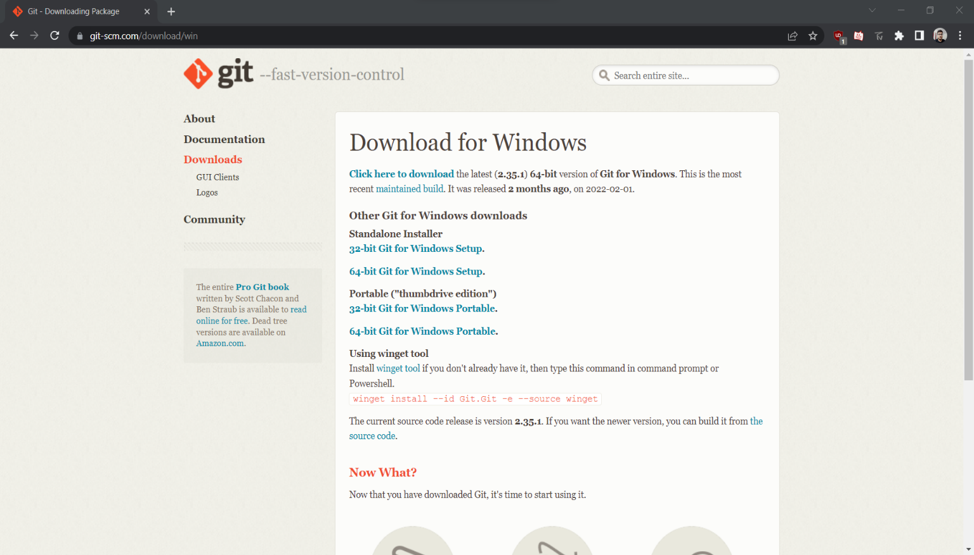After opening this site, you have to select your operating system by clicking on it.
2. Now select the processor of the system you have. (Most of the system are now of 64-bits)
3. After selecting the processor your download will start.
4. Now, you have to open this folder
5. After opening, a prompt notification “Do you want to allow this app to c=make changes in your PC” will pop up. Click YES.
6. 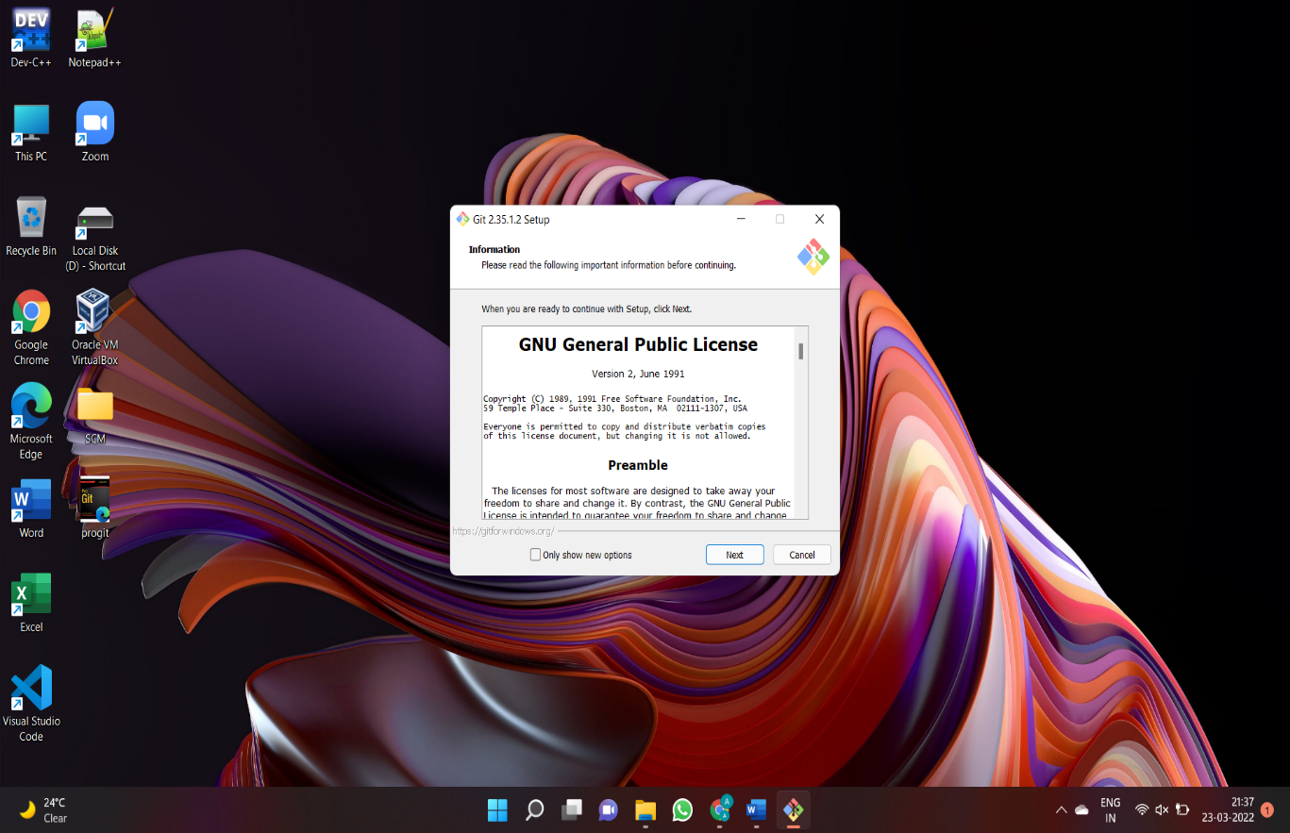Click Next
7. Continue clicking on next few times more
8. Now select the Install option.
9. 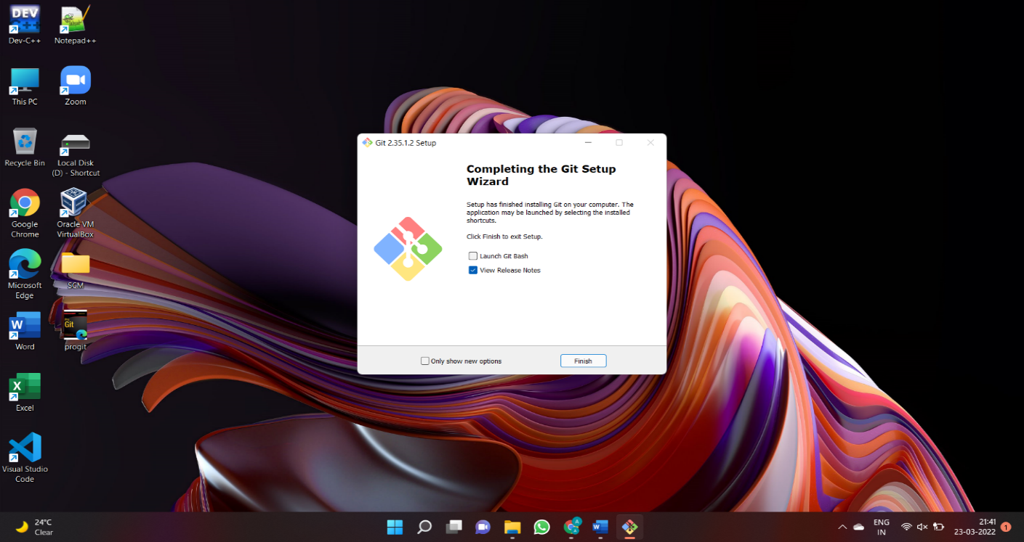 Click on Finish after the installation is finished.



**Experiment No. 02**

**Aim:** To set up GitHub Account

**Procedure:**

1. **Click on** [**https://github.com**](https://github.com) **to open GitHub on browser.**



1. **Type in your email in the Email address box and click on Sign up for GitHub. On the next page click on continue.**

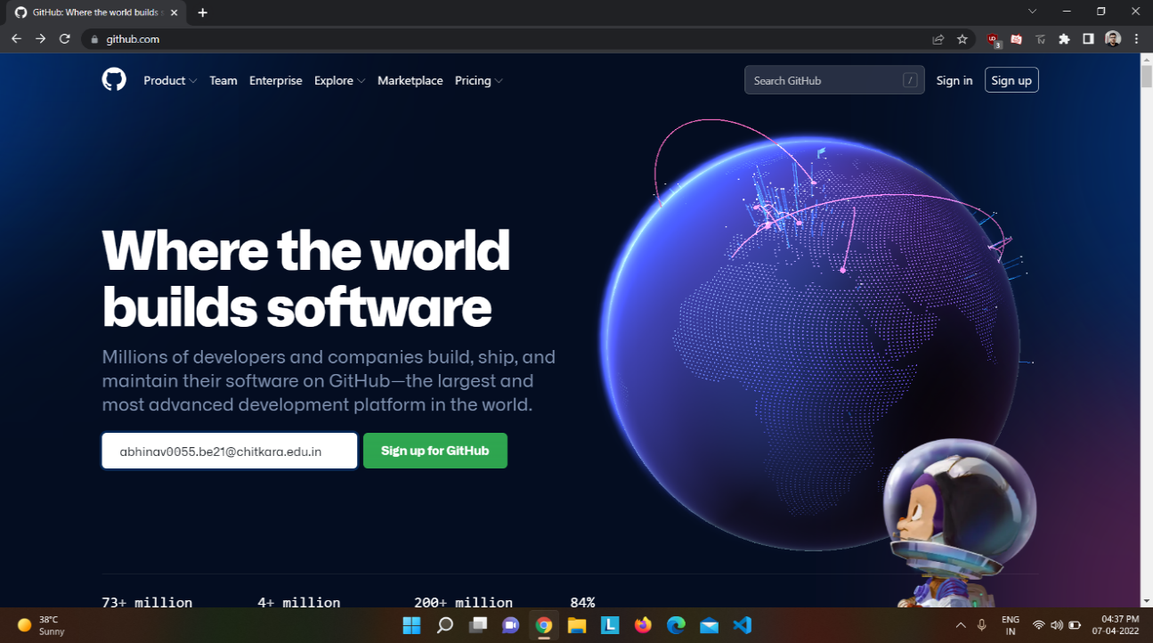

1. 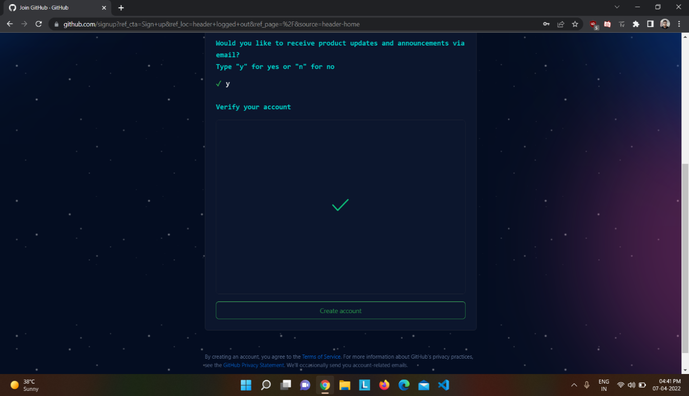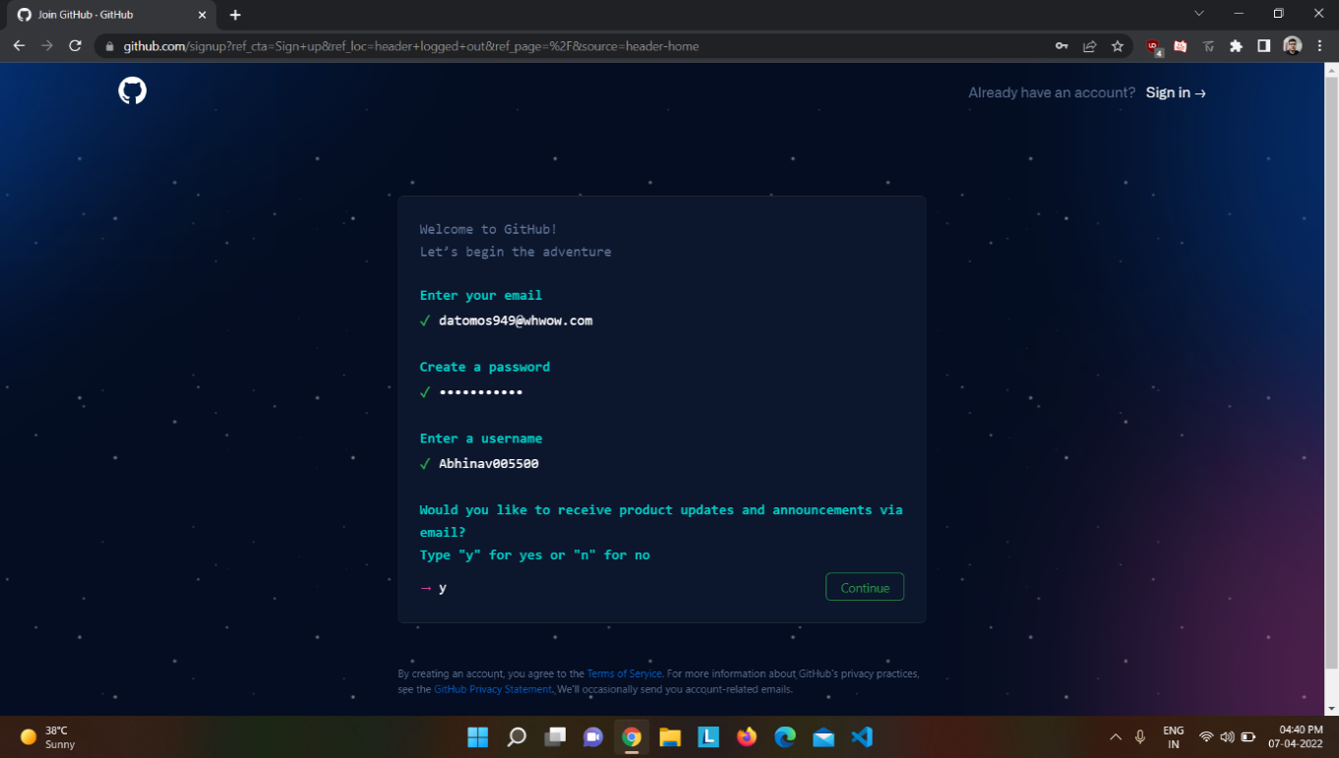**Solve this easy puzzle and Click on Create Account.**

**4. Your homepage of GitHub will be loaded and your GitHub account is all set.**



**Experiment No. 03**

**Aim:** To create a program to generate logs.

**Procedure:**

* **Initialising Git Repository:**

1. 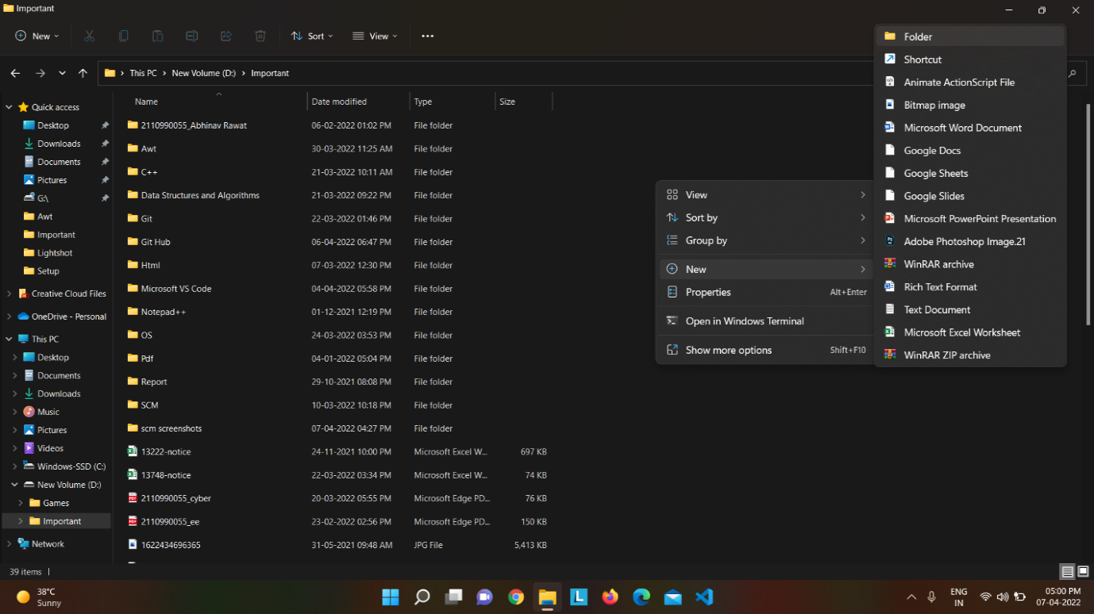**Make a new folder and name it SCM Project.**

**Open the folder and right click on the empty area of the folder.Open Git Bash by clicking on Git Bash Here.**

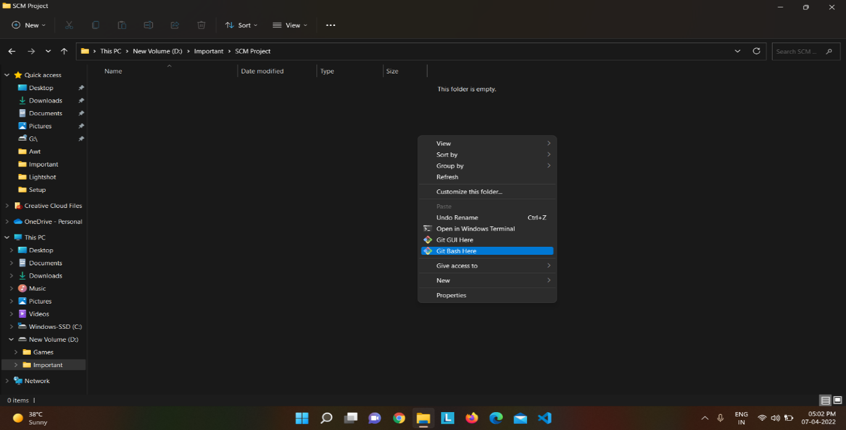**Firstly, check the Present Working Directory by typing the command *pwd* and 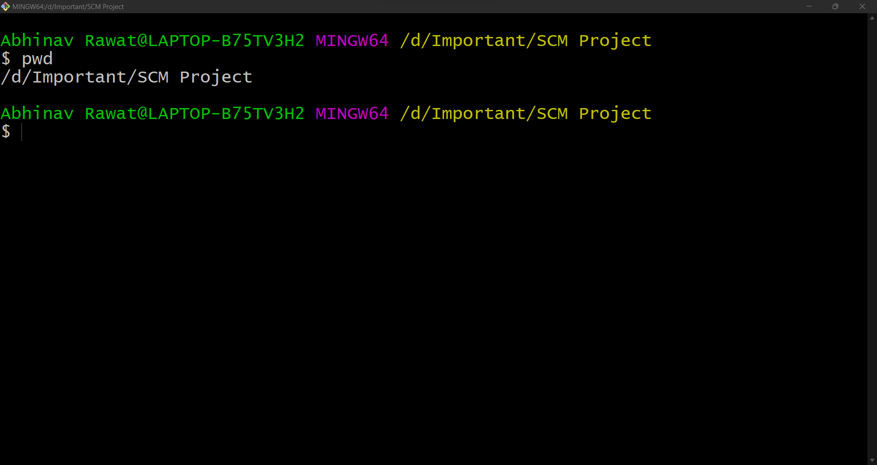press Enter.**

1. **Now, to know every status about the files in the repository, type command *git status***

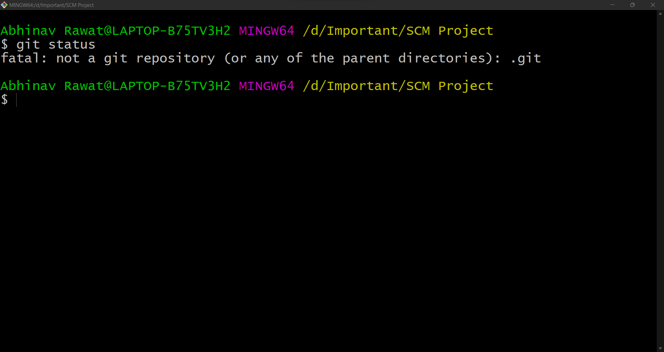

1. 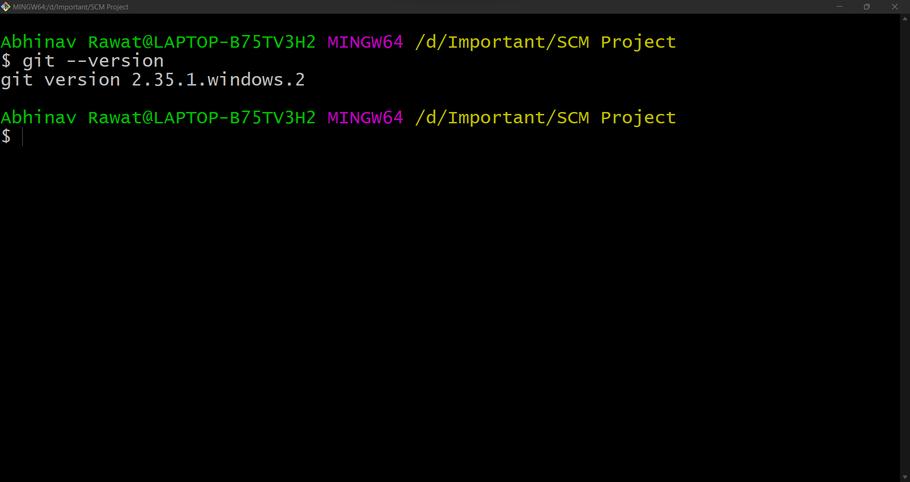**To get the information about the version of your git, type the command *git --version***
2. **Now, to initialize git repository type in command *git init***

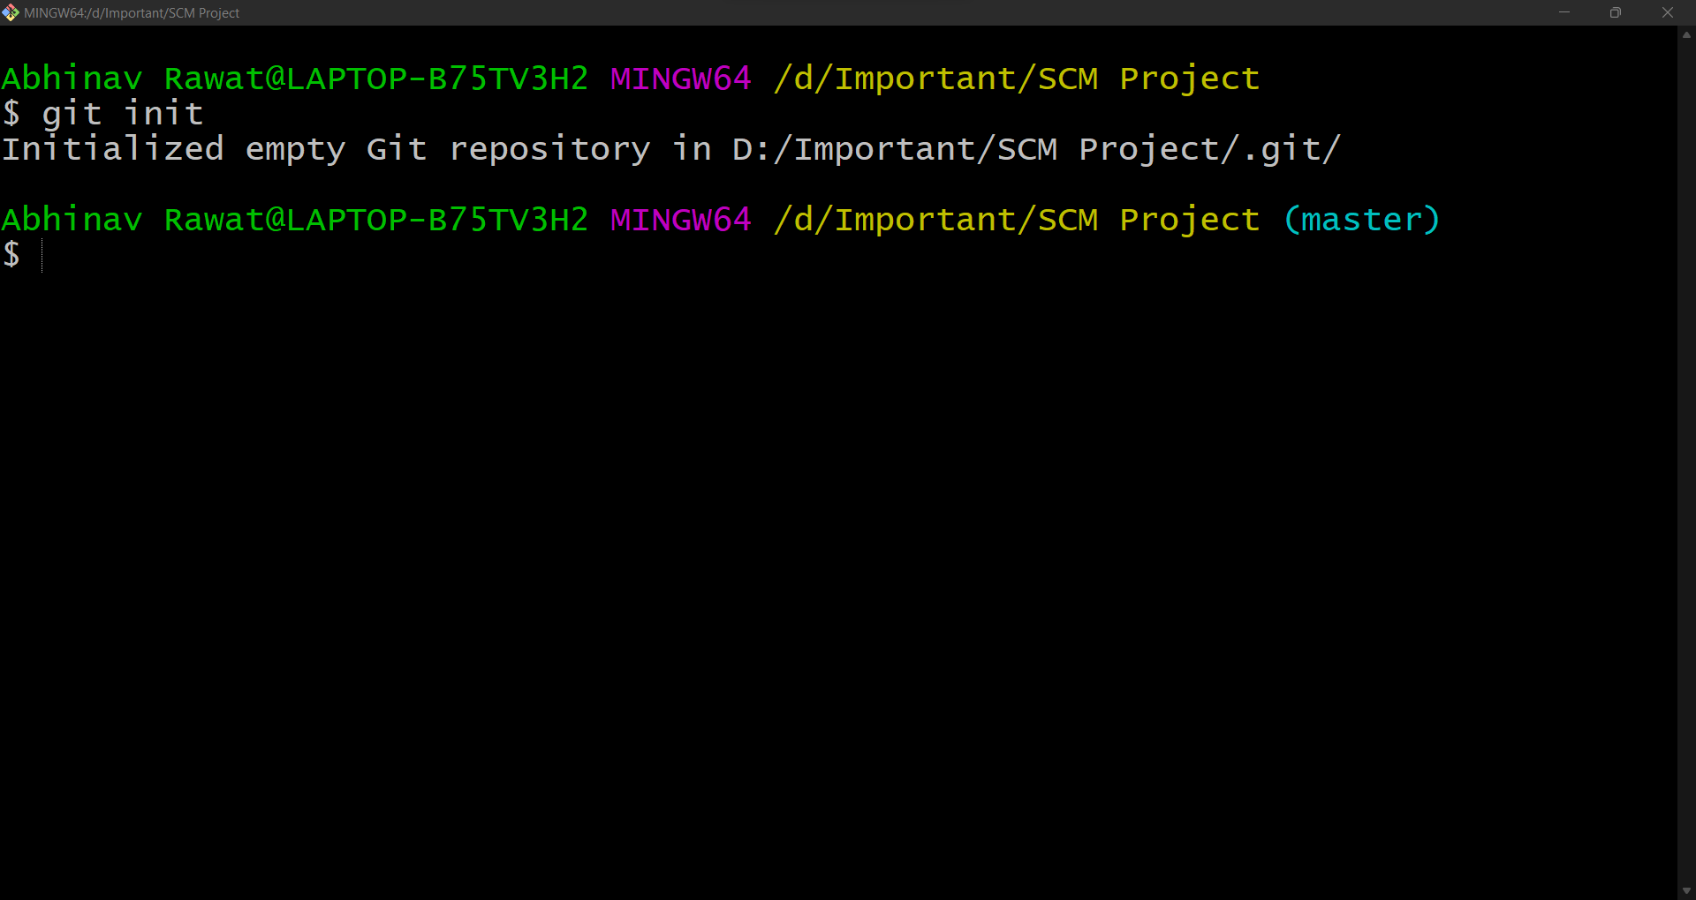

1. **Check the status of your repository.**

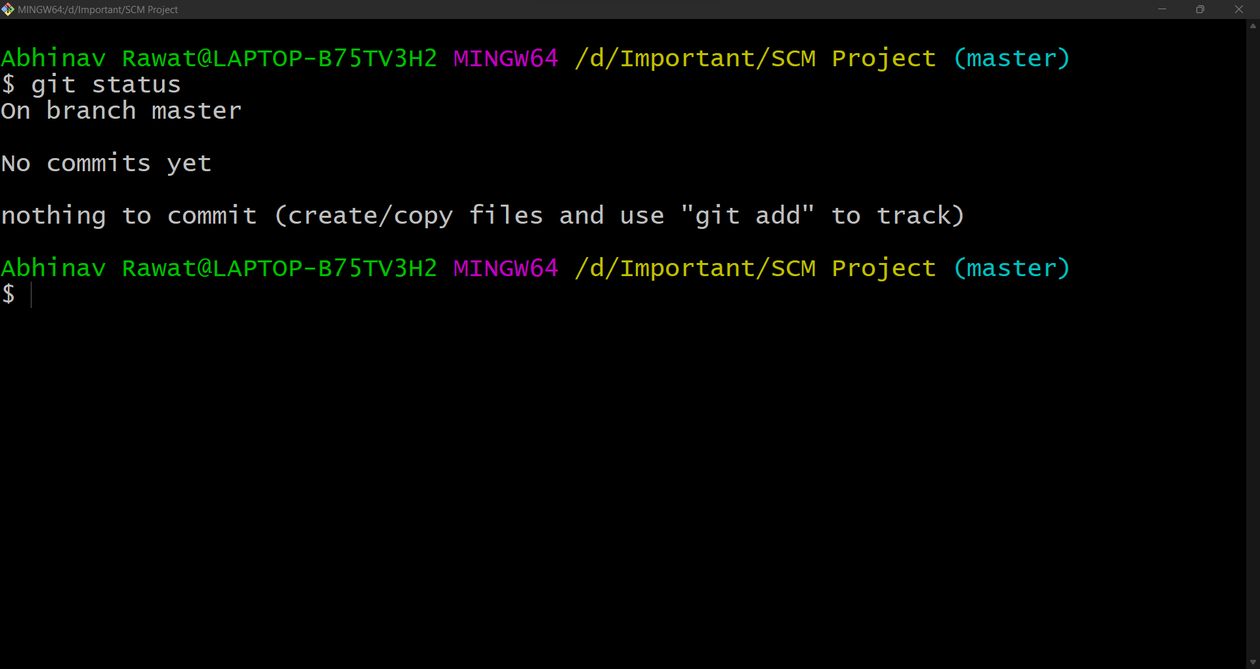**“Nothing to commit” because there are no files in the folder.**

1. **Now go to your folder.**
2. **By default, the .git folder is hidden. To see the .git folder, go to view option and tick the checkbox of Hidden Items and the .git folder will be visible.**

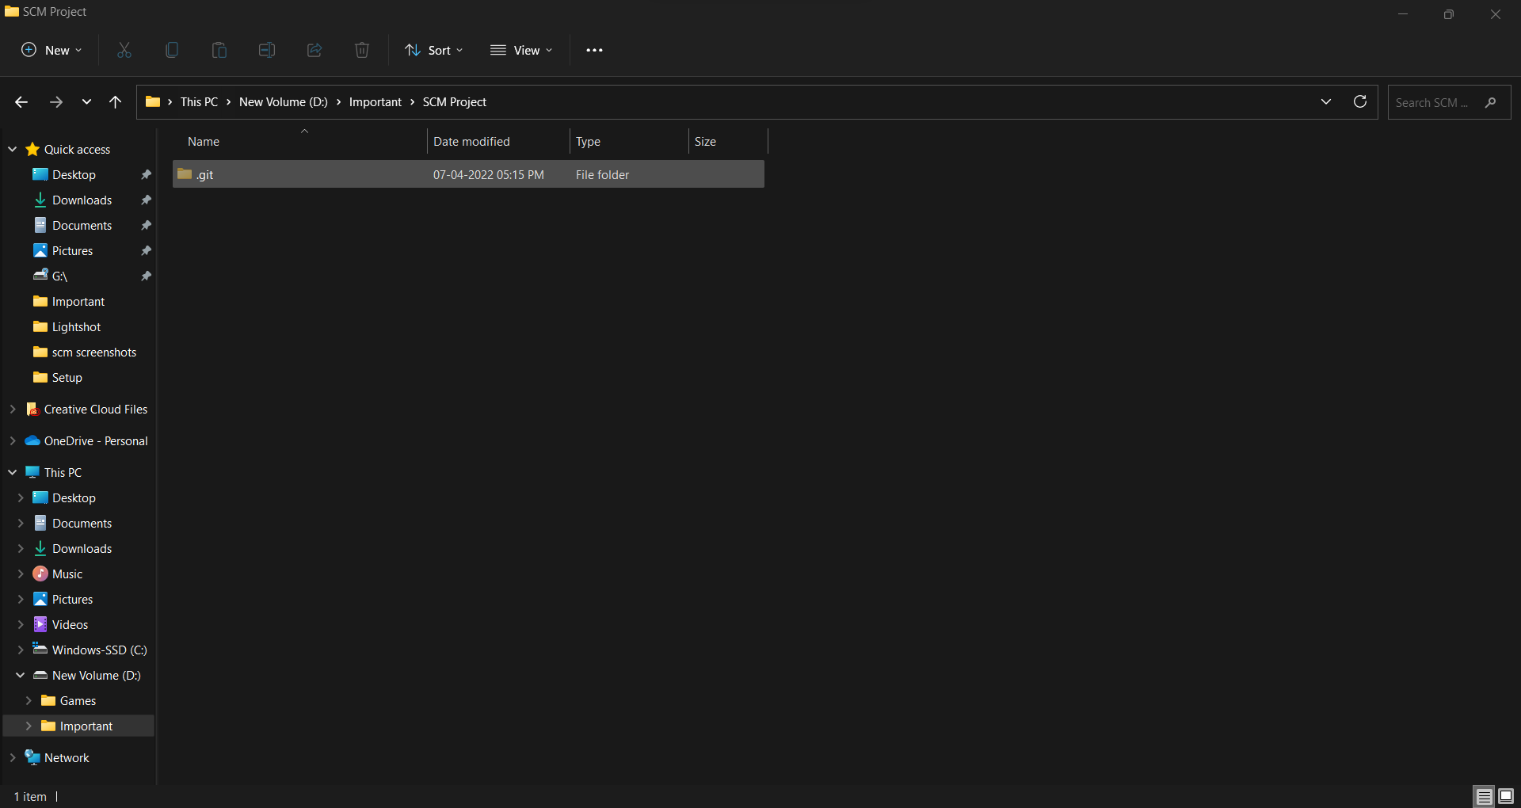**Configuring Username and User Email:**

**So, now that you have successfully created your GitHub account. It is best to use your username and email of GitHub in Git. So, let’s update our username and user email in Git Bash.**

1. **Open Git Bash.**
2. **Type command *git config --global user.name “YOUR USERNAME”.* It will update your username.**
3. 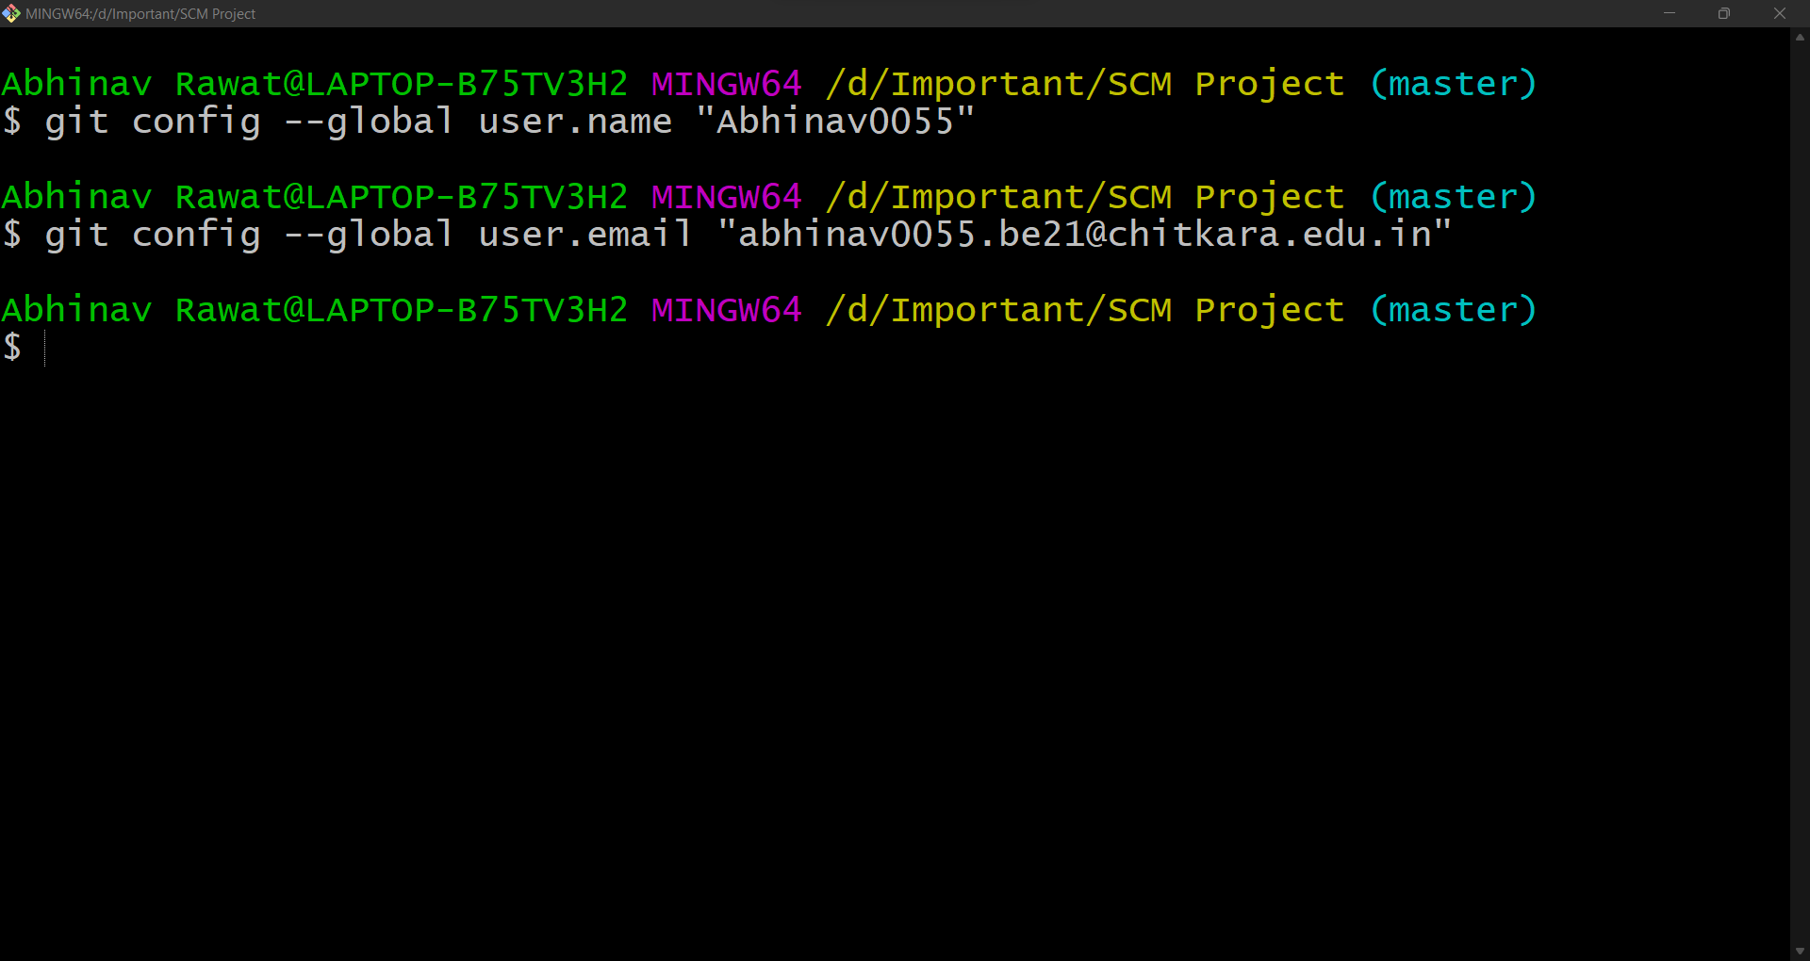**Similarly, you can update your email using the command *git config --global user.email “YOUR EMAIL”*.**
4. **To verify the updated username type command *git config user.name***
5. **Similarly, email can be verified using *git config user.email***

* **Three-Stage Architecture:**

Many VCS’s use a two-stage architecture i.e., a repository and a working copy. Git uses three-stage architecture i.e., a working directory, staging area and local repository.

Working Directory is the folder which we created i.e., SCM Project.

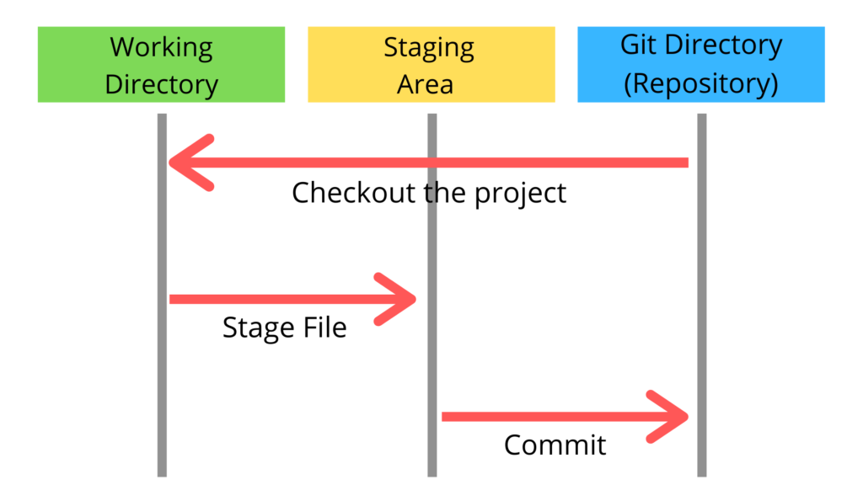Working Directory was converted into Repository where we used ***git init*** command to initial the repository.

Working directory specifies the file explorer’s folder where your files are stored, Staging area is an area where those files are present which you want to send to commit (to create snapshot of files). After commit is fired, files which are in staging area will move to Git Repository.

Now if you made any changes in your files which are in Git repository, those have to be added into the Staging area and Committed.

1. 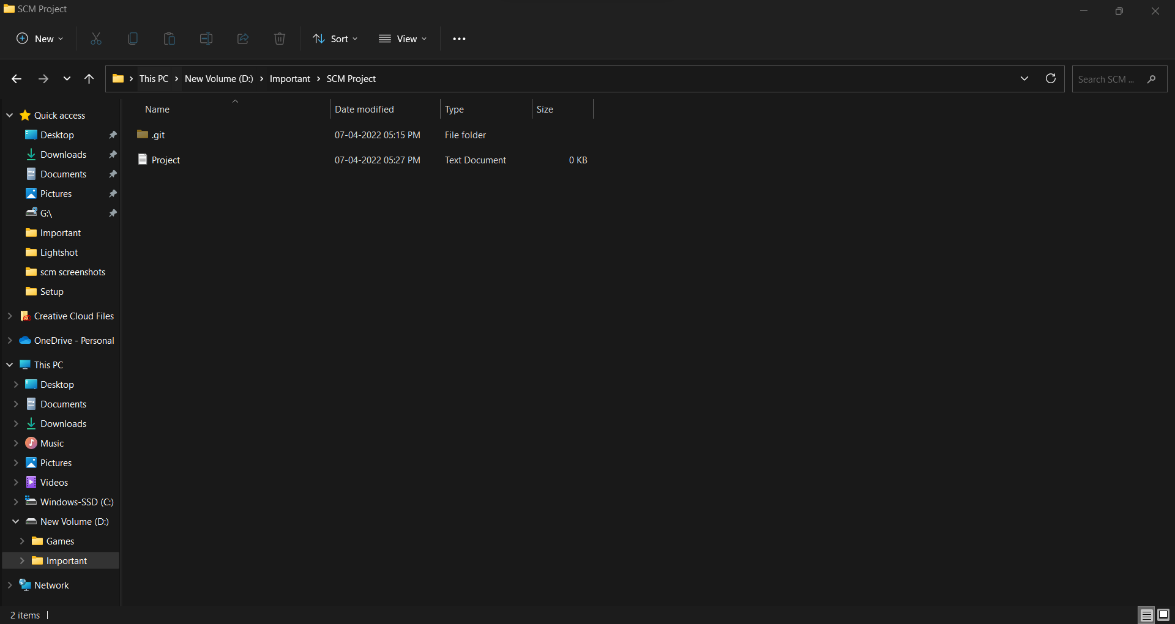**Create a file in the empty Git Repository (SCM Project folder). Let’s create a .txt file and name it as Project.txt.**
2. **Now, open Git Bash and type command *git status***

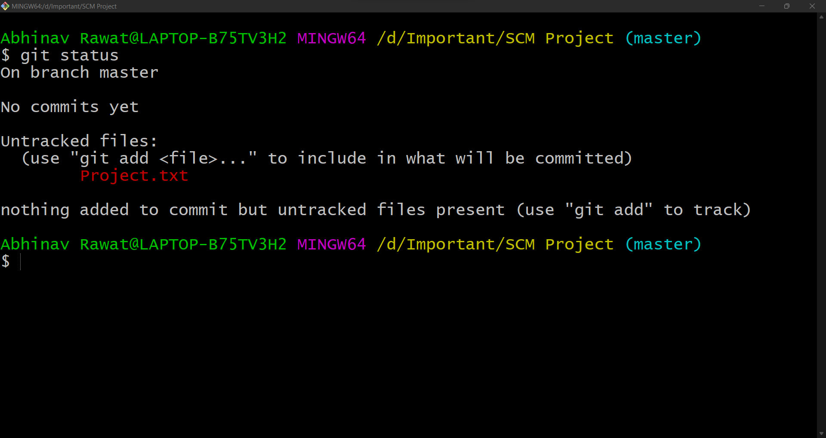**We can clearly see that the Project file is in Untracked files and it is colored in red.**

1. **Now type *git add --a* which will move or add the files to the Staging area. Here --a means all the latest files changed or added. You can also specify a file like *git add design.txt.***
2. 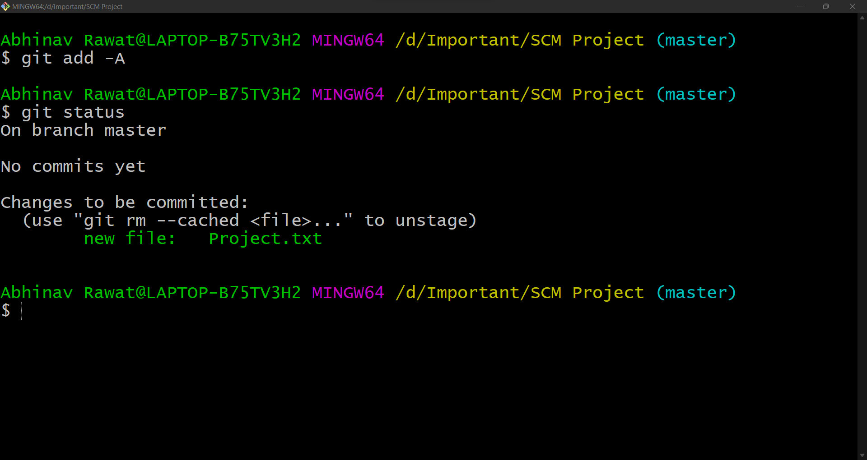After that check status using ***git status***

**Observe that the Project.txt has turned from red to green. This means that file has been added to the staging area and is ready to be committed.**

1. 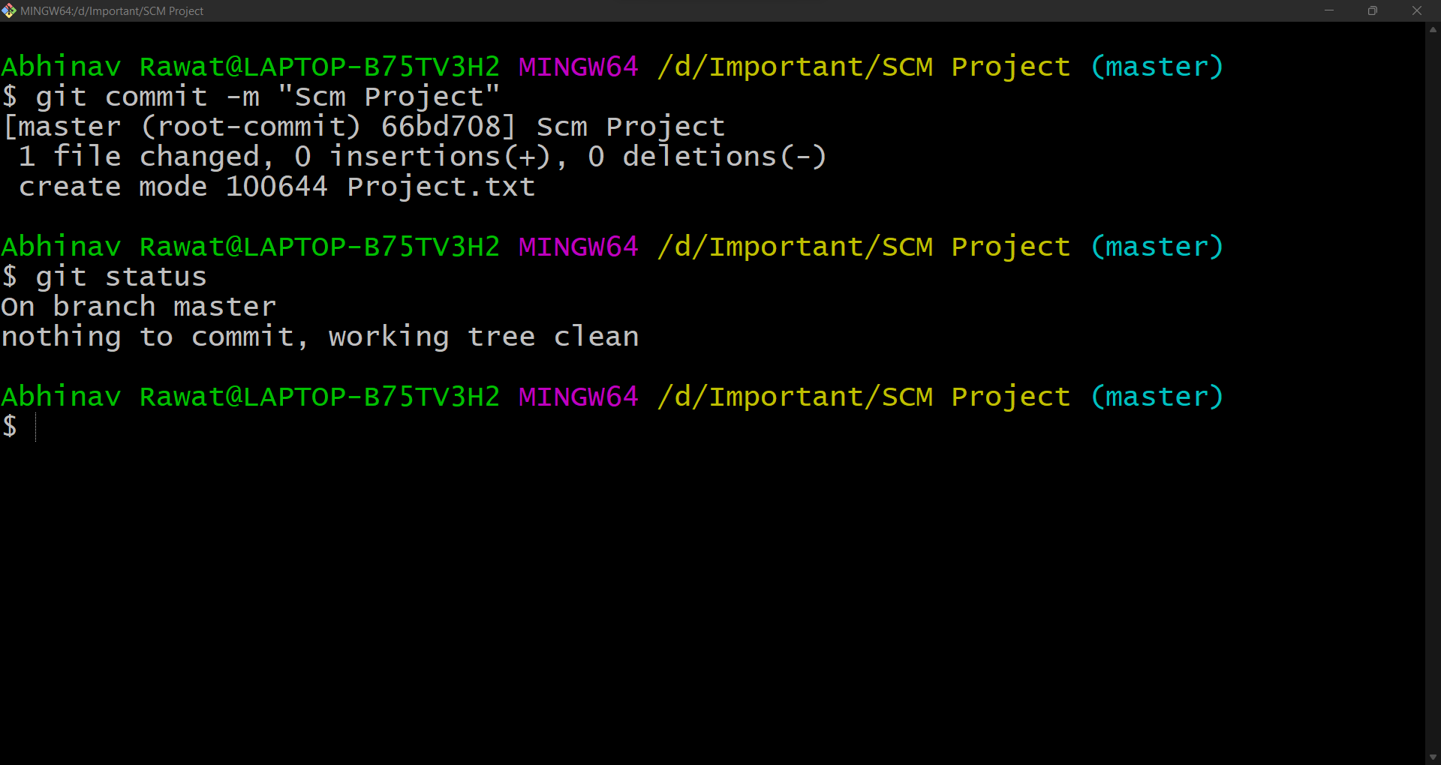**Now to commit the files in the staging area, use command *git commit -m ”Any Message”* and check the status.**
2. 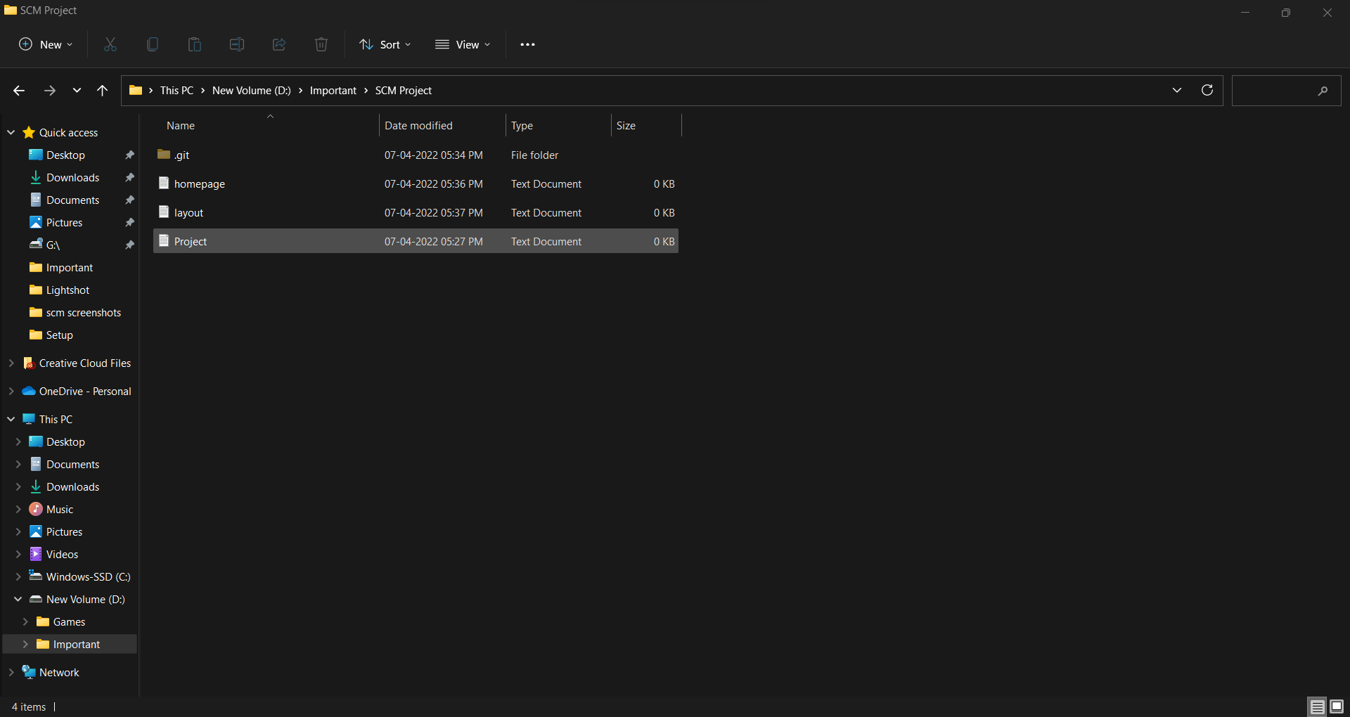**Now create two new .txt files named homepage.txt and layout.txt and typed something and changed the Project.txt file.**
3. 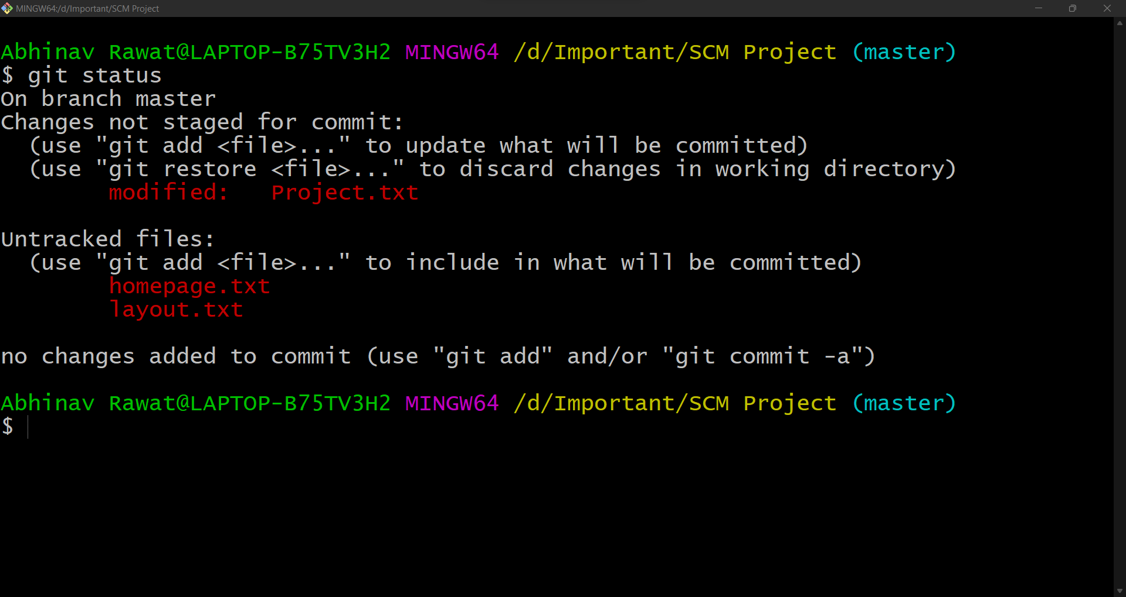**Now let’s check the status. It shows that Project.txt is modified and homepage.txt and layout.txt are untracked. All these changes have to be committed.**
4. 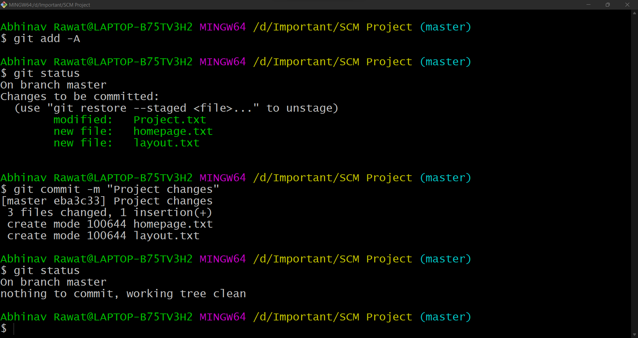**Now we have to commit these changes.**

* **Logs:**

**Git log is a utility tool to review and read a history of everything that happens to a repository.**

**Every change committed and the message corresponding to it is recorded and can be seen in the git log.**

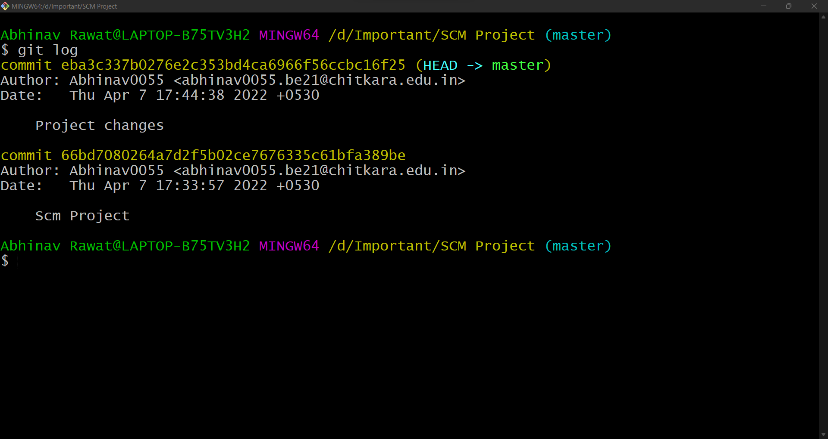**Command for Git Log is *git log***



**Experiment No. 04**

**Aim:** To create and visualize branches.

**Theory:** Nearly every VCS has some form of branching support. Branching means you diverge from the main line of development and continue to do work without messing with that main line.

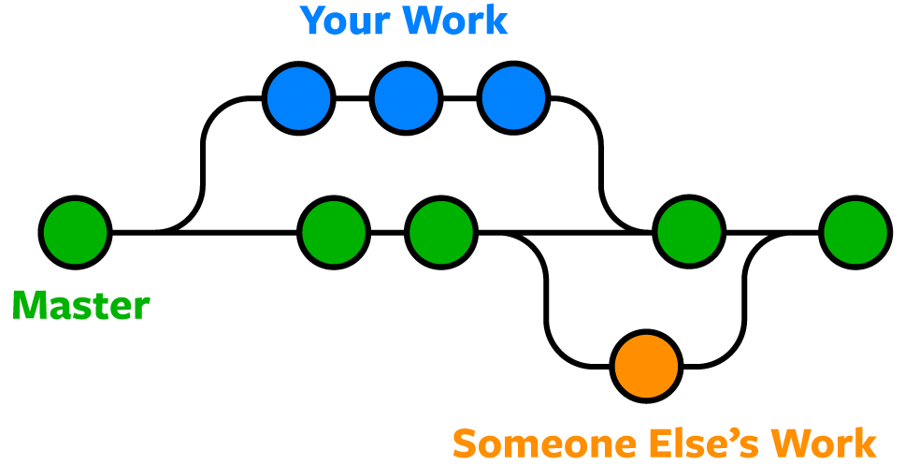Branching simply means parallel development.

**Suppose your team is making a website on the master. You did your work and you think that you can make the website better and you want to do some experiments. Without messing with the website, you can experiment with it using this amazing feature git provides us i.e., branching.**

**Whenever we create a child branch from a parent branch, all the data will be copied in child branch. But any changed after committing in child will not reflect in parent branch. Similarly, any changes in parent branch after creating child branch, won’t be reflected in child branch.**

**Procedure:**

1. **Open Git Bash and type the command *git branch***

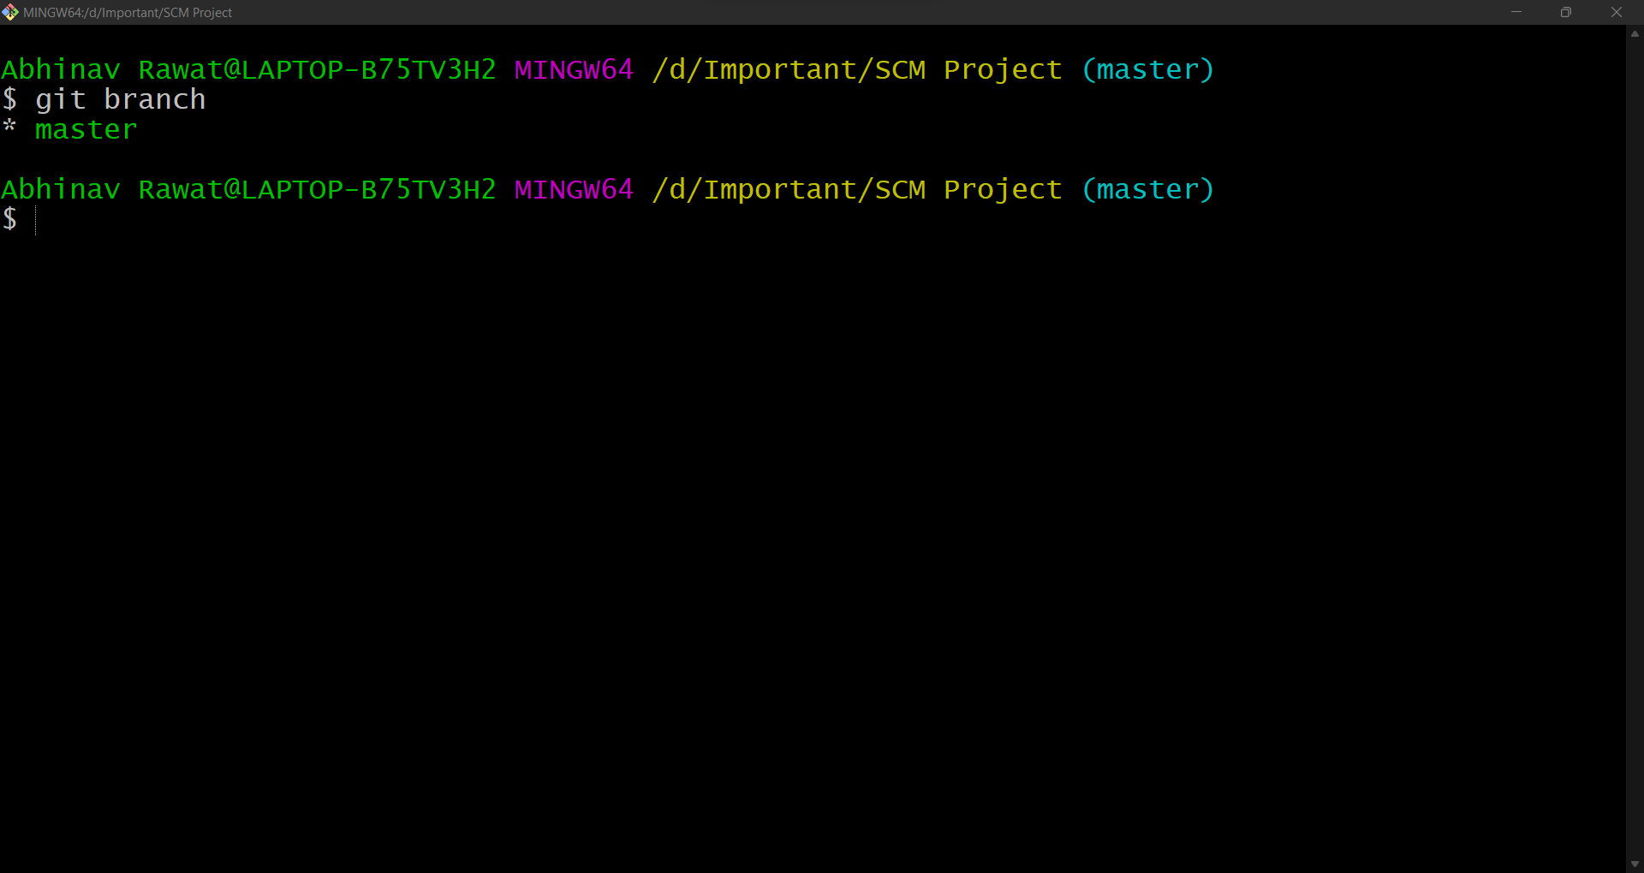

**Master branch is the default and main branch. Green colour means that this branch active at the moment.** ***git branch* command shows the list of all the branches.**

1. **To create a new branch from master, use the command *git branch <Name of the branch>***

**Let’s take for example create two branches from master branch**

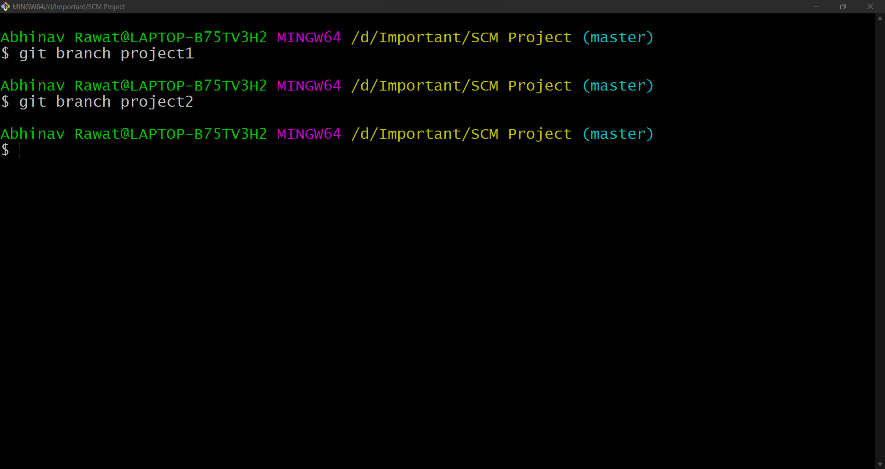***git branch project1* and *git branch project2.***

1. **To see all the branches, use command *git branch***
2. 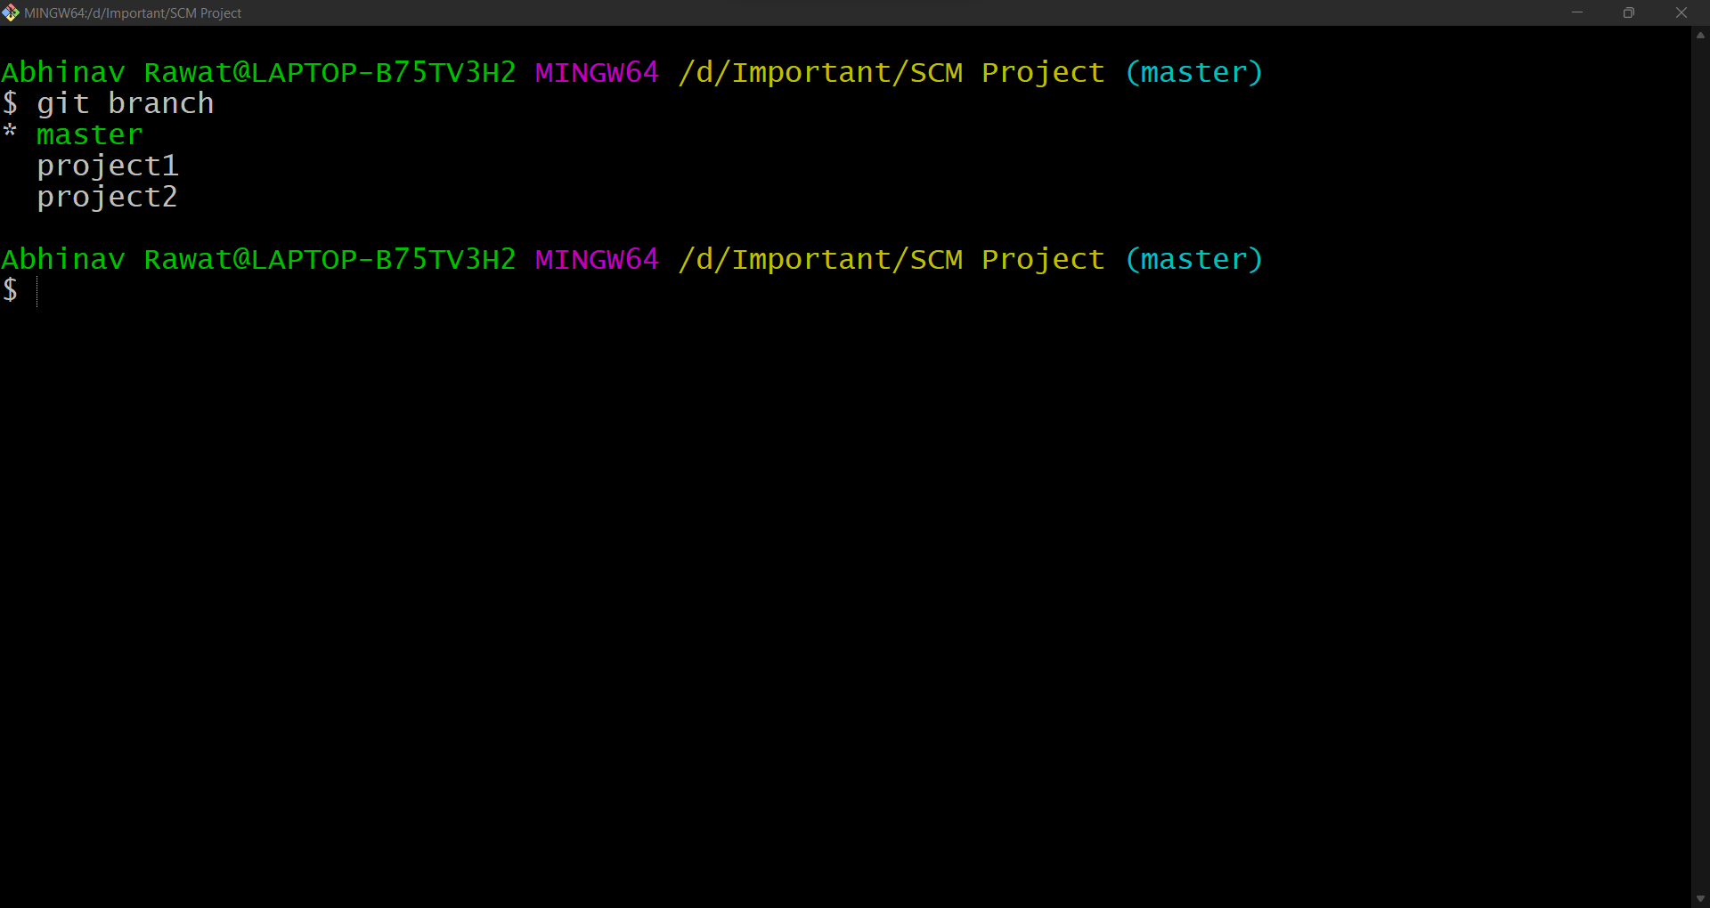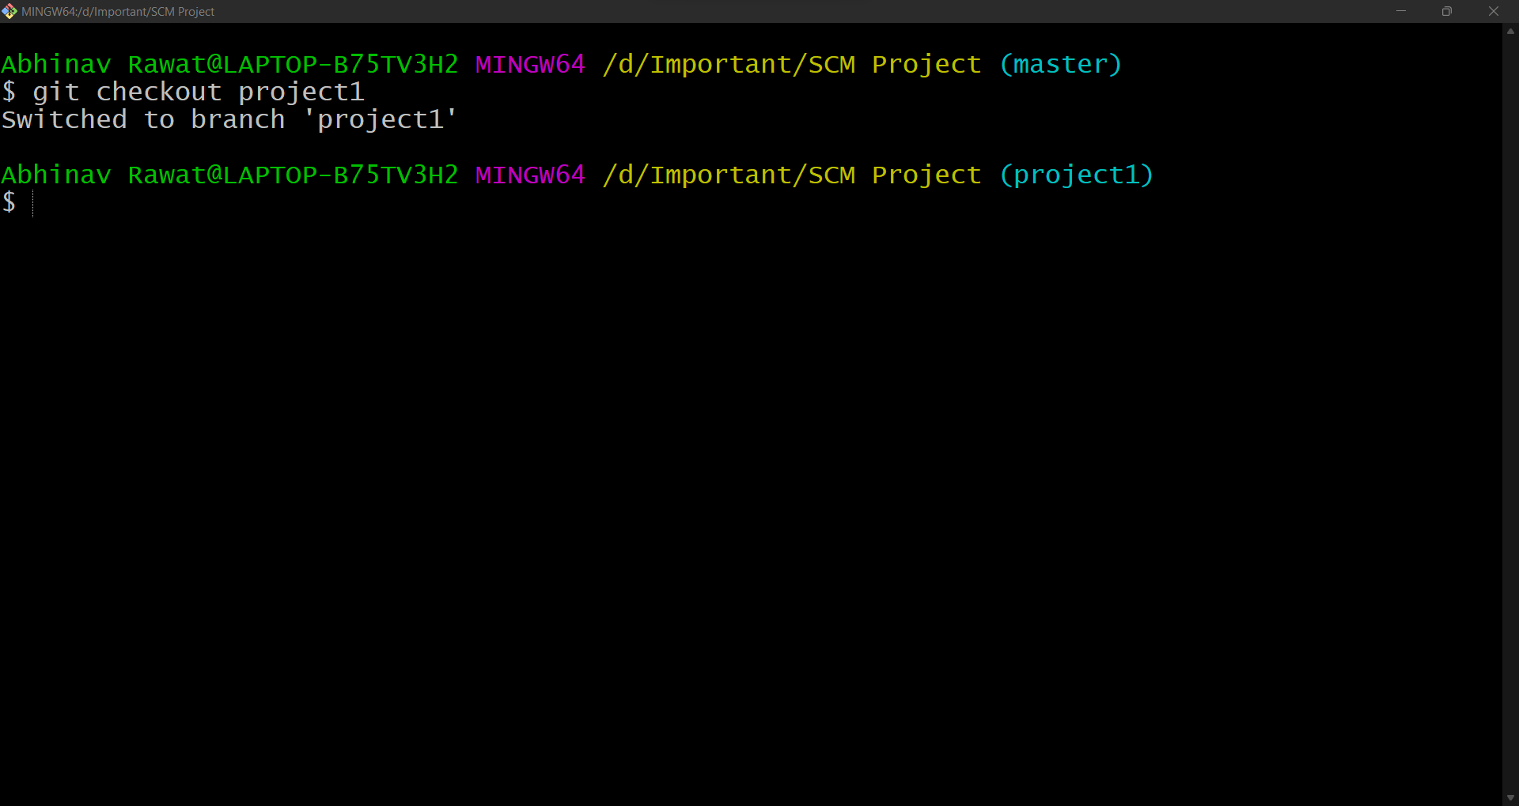**Now, to shift or go to the newly created branches use the command *git checkout project1.***

**Now, we can clearly see that it is switched to the branch project1 as it is returned by the program and in cyan color the master has changed to project1.**

**To double verify we can use the command *git branch***

**It can be clearly seen that activity has turned green**

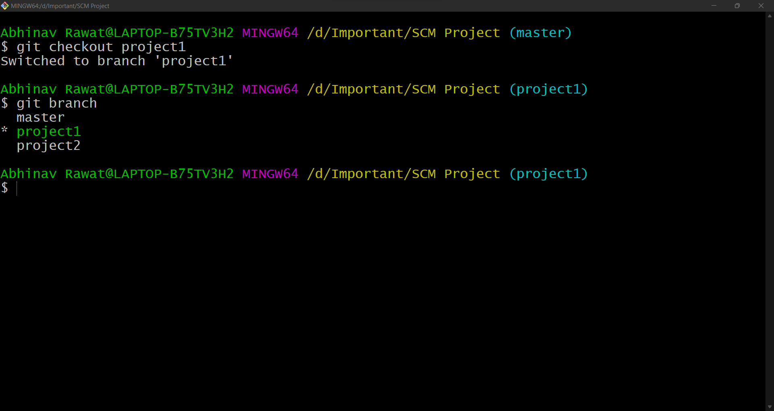

1. **Now make some changes in the folder. For example: Make two new txt files named prj1file1.txt and prj1file2.txt**

**And make some changes in Project.txt**

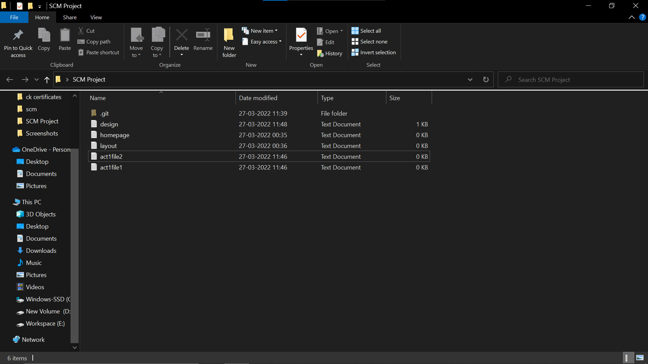

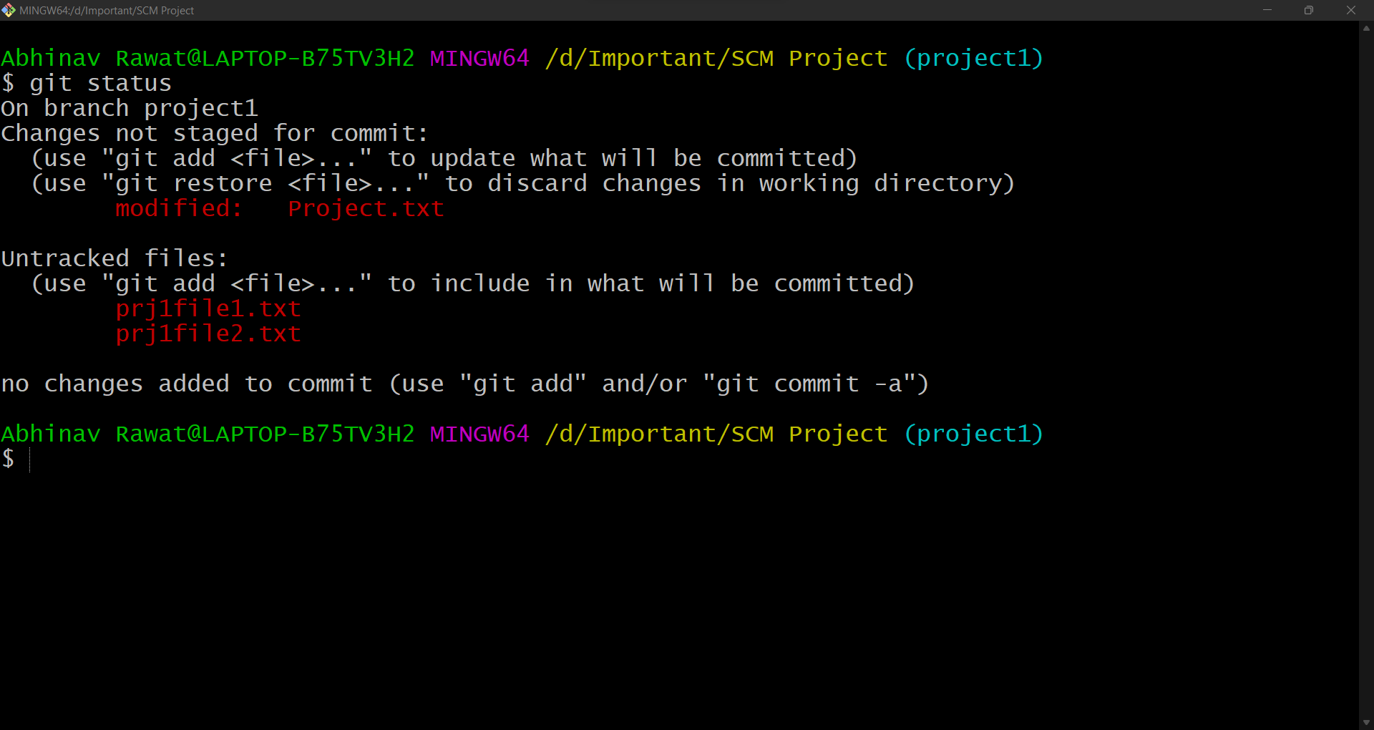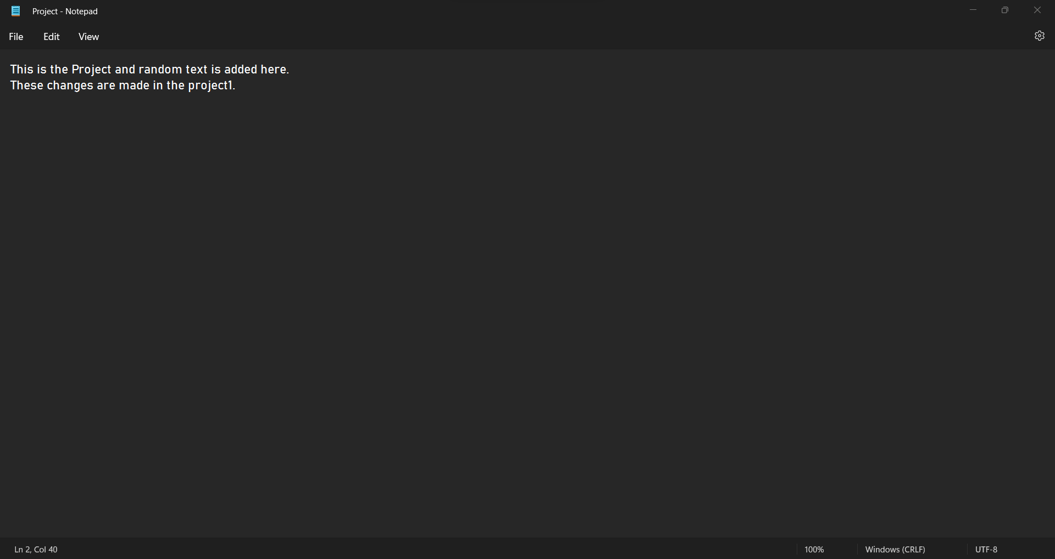

1. 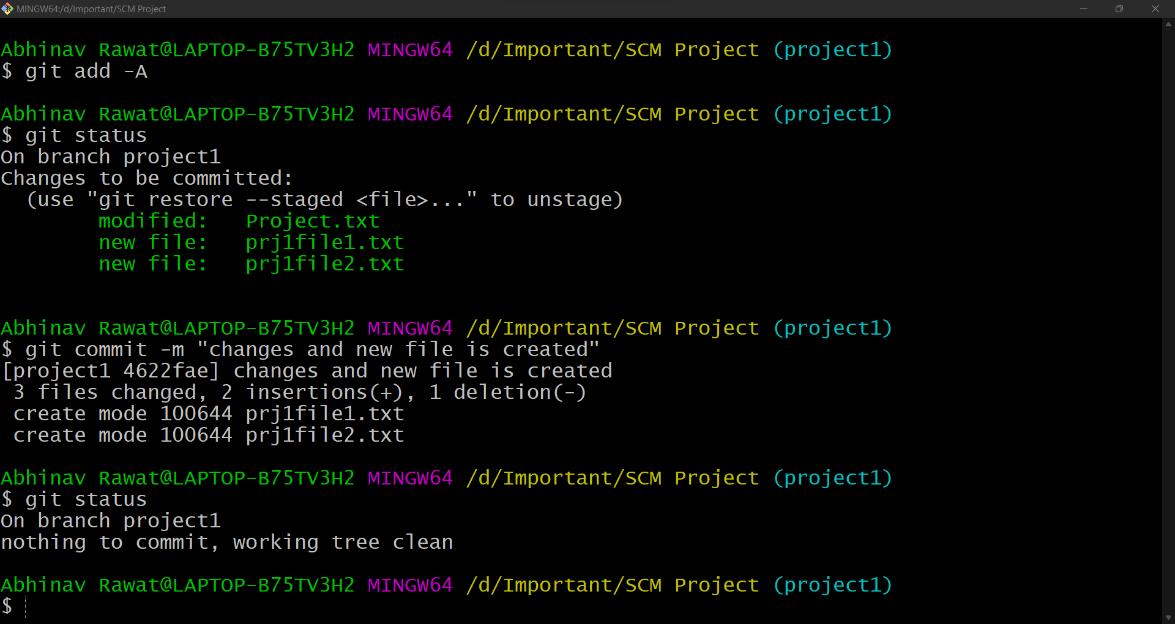**Now we have to add the changes or new files to staging area and then commit them.**
2. 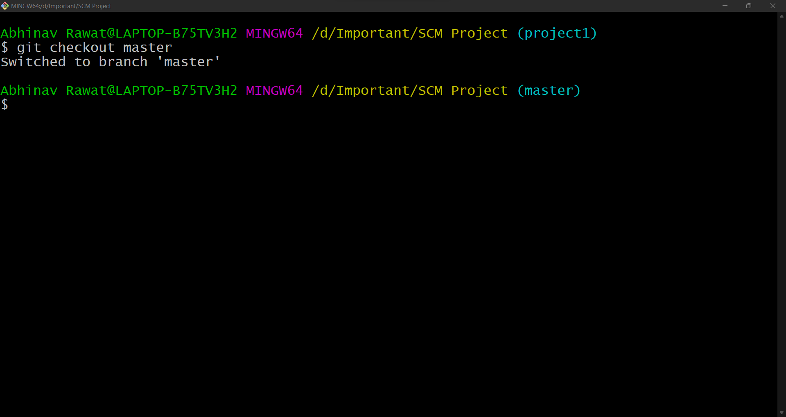**Now let’s go back to the master branch using the command *git checkout master***
3. **Check the SCM Project folder, there are no act1file1.txt and act1file2.txt and design file has not changed like we did in activity1 branch.**

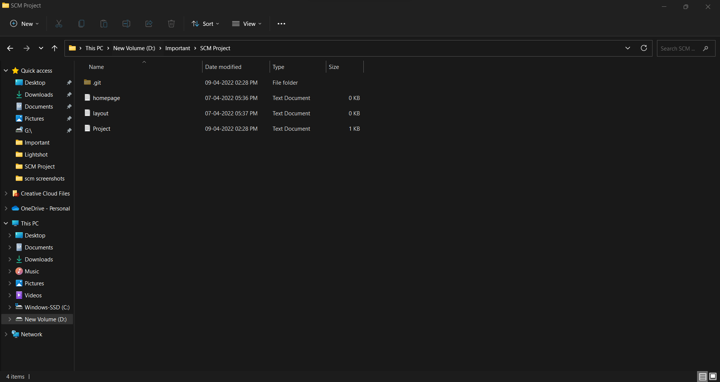

**So, this proves that any changes done in child branch will not reflect in parent branch after committing the changes.**



**Experiment No. 05**

**Aim:** To describe Git Lifecycle.

Many VCS’s use a two-stage architecture i.e., a repository and a working copy. Git uses three-stage architecture i.e., a working directory, staging area and local repository.

Working Directory is the folder which we created i.e., SCM Project.

Working Directory was converted into Repository where we used ***git init*** command to initial the repository.

Working directory specifies the file explorer’s folder where your files are stored, Staging area is an area where those files are present which you want to send to commit (to create snapshot of files). After commit is fired, files which are in staging area will move to Git Repository.

Now if you made any changes in your files which are in Git repository, those have to be added into the Staging area and Committed.

1. **Create a file in the empty Git Repository (SCM Project folder). Let’s create a .txt file and name it as Project.txt.**
2. **Now, open Git Bash and type command *git status***

**We can clearly see that the Project file is in Untracked files and it is colored in red.**

1. **Now type *git add --a* which will move or add the files to the Staging area. Here --a means all the latest files changed or added. You can also specify a file like *git add design.txt.***
2. After that check status using ***git status***

**Observe that the design.txt has turned from red to green. This means that file has been added to the staging area and is ready to be committed.**

1. **Now to commit the files in the staging area, use command *git commit -m ”Any Message”* and check the status.**
2. **Now create two new .txt files named homepage.txt and layout.txt and typed something and changed the Project.txt file.**
3. **Now let’s check the status. It shows that Project.txt is modified and homepage.txt and layout.txt are untracked. All these changes have to be committed.**
4. **Now we have to commit these changes.**